MzDOCK: a free ready-to-use GUI based pipeline for molecular docking simulations

Muzammil Kabier1, Nicola Gambacorta2, Daniela Trisciuzzi3, Sunil Kumar1, Orazio Nicolotti3,*Bijo Mathew1*

*1 Department of Pharmaceutical Chemistry, Amrita School of Pharmacy, Amrita Vishwa Vidyapeetham, AIMS Health Sciences Campus, Kochi, India. (kabeermuzammil614@gmail.com(M.K,); solankimedchem@gmail.com( S.K.); bijovilaventgu@gmail.com (B.M.)*

*2 Division of Medical Genetics, IRCSS Foundation-Casa Sollievo della Sofferenza, San Giovanni Rotondo (Foggia), Italy*

*3Dipartimento di Farmacia Scienze del Farmaco, Università degli Studi di Bari “Aldo Moro”, Via E. Orabona, 4,*

*I-70125 Bari, Italy.*

**\***Correspondence : Bijo Mathew ([bijovilaventgu@gmail.com](mailto:bijovilaventgu@gmail.com); [bijomathew@aims.amrita.edu](mailto:bijomathew@aims.amrita.edu));

Orazio Nicolotti (orazio.nicolotti@uniba.it)

**MzDOCK step-by-step user guide**

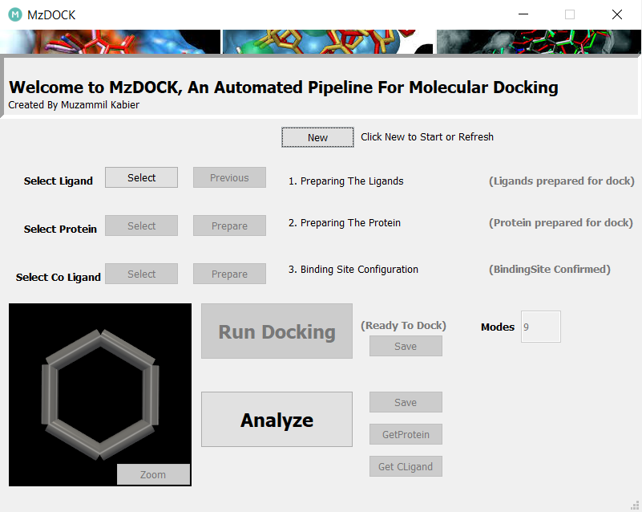

Figure SX1: Home page of MzDOCK software

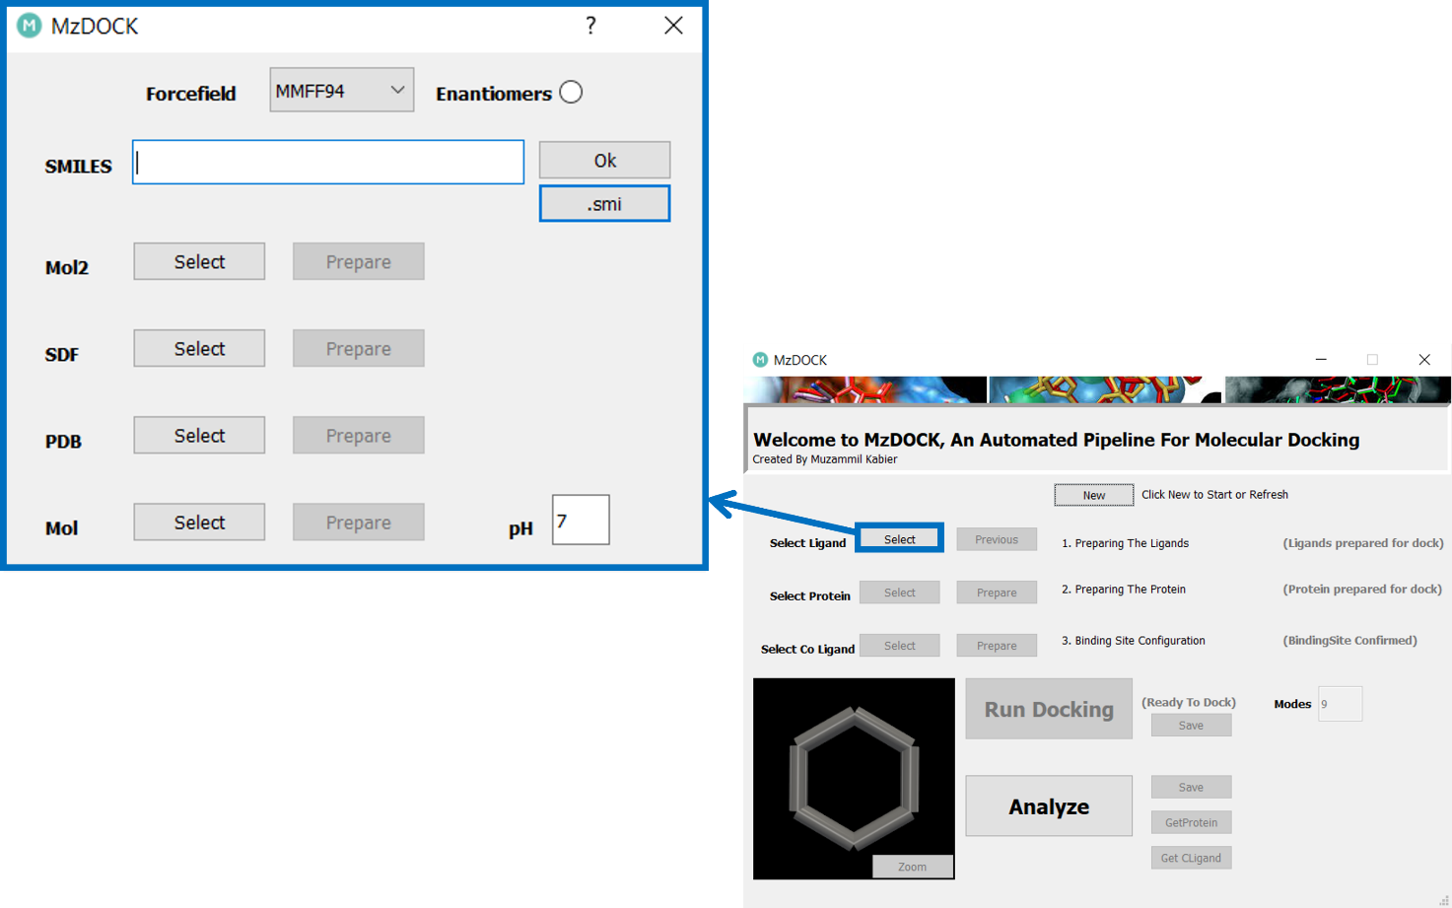

Figure SX2: Ligand preparation box of MzDOCK software

As shown in Figure SX2, the ligand preparation box offers the option to choose the molecular format from among .smi, .mol2, .sdf, .pdb, and .mol files. Additionally, users can select the force field to be used, as well as compute different enantiomers. Users also have the flexibility to set a custom pH value to accurately calculate tautomers or protonation states, with a default value set at 7.

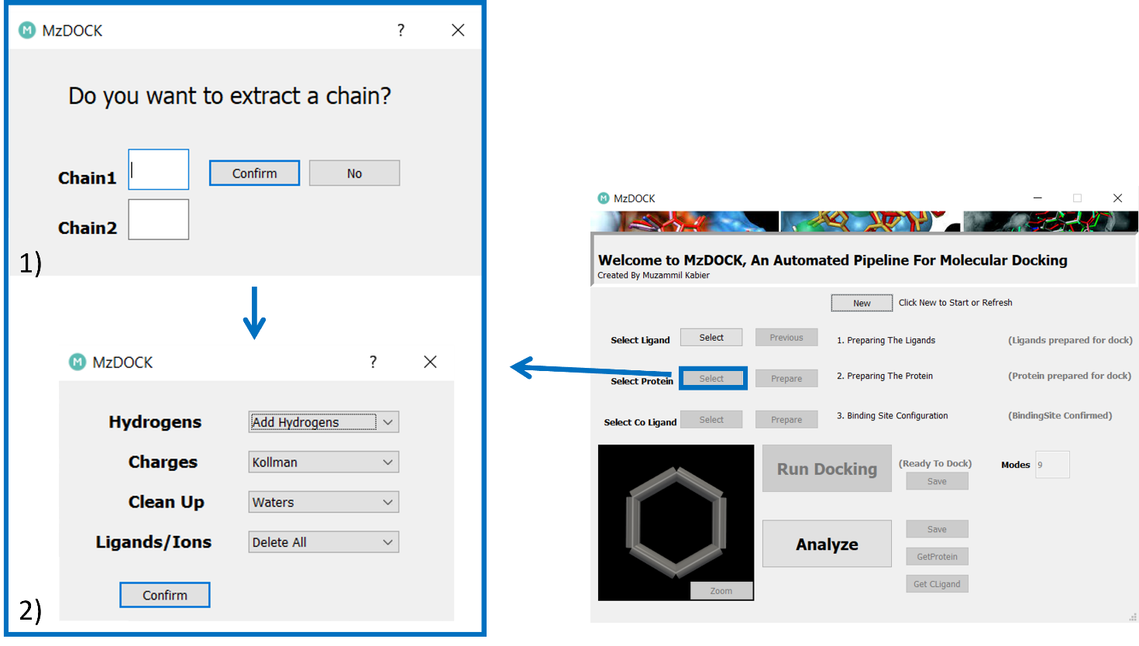

Figure SX3: Protein preparation box of MzDOCK software

The protein preparation box, shown in Figure SX3 allows to extract a specific chain of a .pdb file, if present, and subsequently to compute Kollman or Gasteiger charges, to delete/retain water molecules or specific ions or cofactors.

For Retaining water, select ‘keep water’ from ‘clean up’ combobox and in Ligands/ions the option ‘manual’ is chosen where the user should add HOH and press confirm

For retaining a specific ion or co-factor, the user must provide the 3-letter code or 2 letter codes for single atoms. This code must match with that in the PDB file. (NOTE* The single atoms code for eg: ‘ZN’ must be given with a space to the left

Eventually, by clicking on the ‘Confirm button, the target protein is prepared accordingly.

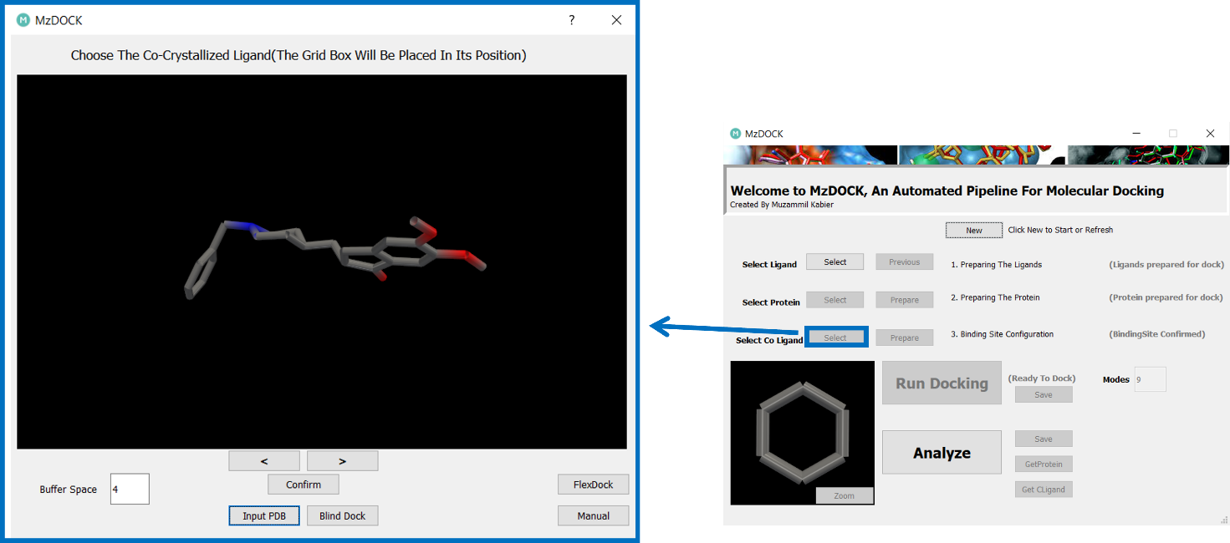

Figure SX4: Receptor Grid preparation box of MzDOCK software.

The grid box generation (Figure SX4) is carried out within an *in-house* created dialog box, in which the user can swap through the ligand around upon which to build the grid. Furthermore, the option for setting the gridbox within specific cartesian coordinates has been also implemented by clicking the ‘Manual’ button. ‘InputPDB’ can be used to provide PDB which user generate as input for customized binding site grid box to be placed on that specific PDB file relative to the main PDB file. With this option, user can input a probe pdb ligand or a set of residues which is relative to the main PDB (NOTE*- The buffer space must be changed as per users need before clicking on the InputPDB button). Users can use ‘Blinddock’ option to set grid box containing the whole of protein.

Moreover, the FlexDock button allows enabling the flexible docking simulation.

There are two protocols for performing flexible docking with MzDOCK, as summarized in Figure SX5:

1. The user selects the co-crystallized ligand in the swap window before clicking the “FlexDock” button; residues within a user specified distanceof the selected ligand are marked as flexible. The upper limit is 6 Angstrom. This is to limit the user from setting residues as flexible beyond search space which would result in an unsuccessful docking. The default search space from the co-crystallized ligand is 10 angstrom this is set to consider both binding on the site as well as provide enough space for residue flexibility.
2. The user has the option to manually choose residues. A comprehensive list of all residues is displayed in the “Residues” section. From this list, the user can add residues to the “Selected Residue” list which will then be designated as flexible. A "Search Neighbor" panel is available to locate all potential residues within the user-specified distance in angstroms. It returns residues that fall within the provided parameters.

Figure SX5: FlexDock box of MzDOCK software.

By clicking the "Run Docking" button, users initiate the molecular docking computation, specifying the number of poses for each ligand. The outputs are saved in a directory designated by the user, comprising a .txt file containing docking score values in kcal/mol, along with .pdb files of the docked ligand and protein.

Finally, the “Analyze” button is used to automatically generate the .pse file containing the protein-ligand complex and a .txt file including information about the interactions type and bond distances.